MIKROLOKACIJA A – prvi dio

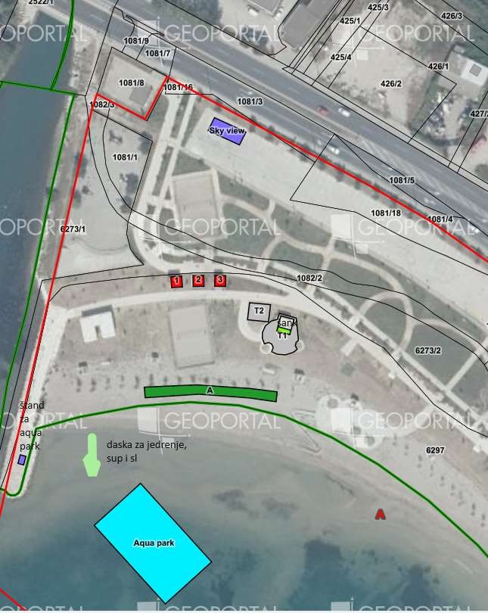

MIKROLOKACIJA A – drugi dio

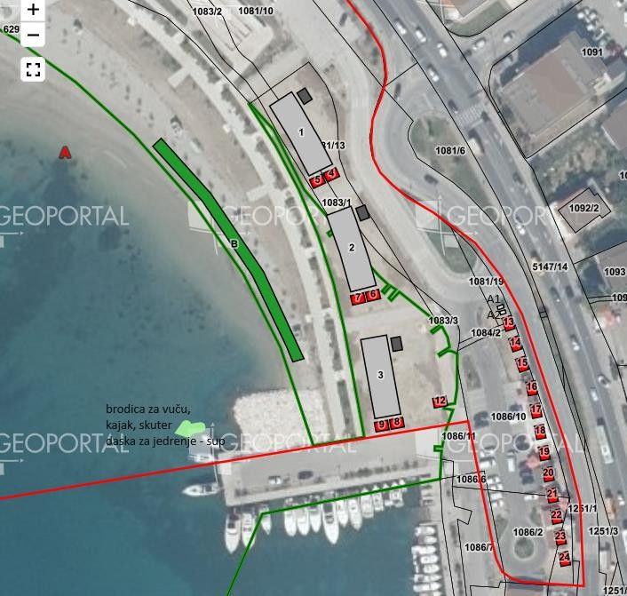

PLAN UPRAVLJANJA POMORSKIM DOBROM NA PODRUČJU OPĆINE PODSTRANA ZA RAZDOBLJE 2024.- 2028. GODINE

MIKROLOKACIJA B



